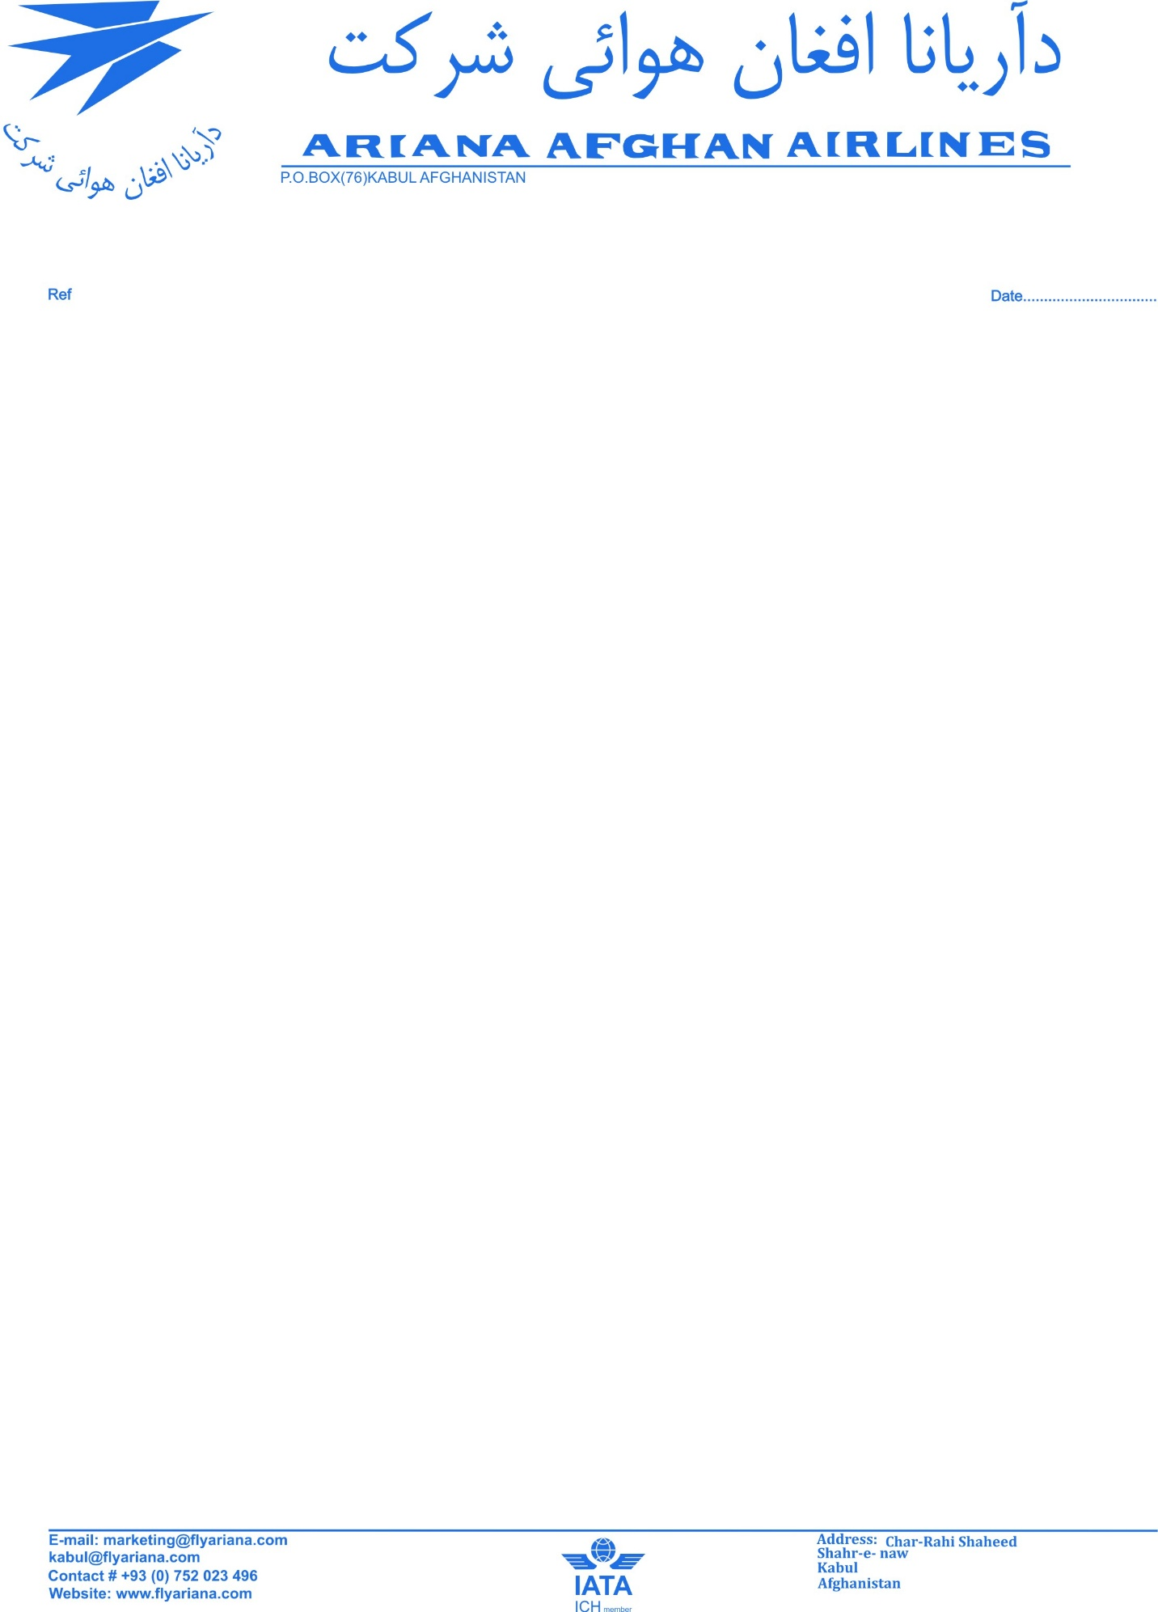
AIRCRAFT GENERAL DATA
Aircraft |  |  |  | Performance Data
Aircraft Model |  | AN 24 RV |  | Max. Take Off Gross Weight |  | 21800 Kg
Aircraft Type Certificate No |  |  |  | Max. Taxi Weight |  | 21500 Kg
Manufacture Date |  | 3.05.1973 |  | Max. Zero Fuel Weight |  | 18100 Kg
Serial Number |  | 37308605 |  | Max. Landing Weight |  | 21800 Kg
Registration |  | YA-CAH |  | Basic Empty Weight |  | 14870 Kg
TSN |  | 17403 H |  | Fuel Capacity |  | 5000 Kg
CSN |  | 39025 C
Owner |  | Afgahn Government
TIME BETWEEN O/H |  | 5000 FH 5 YEARS
REM. |  | 1406 FH /DUE 31.07.2010
Power Plant |  |  |  |  | APU
Engine Model | A124-2 |  |  |  | APU Model |  | RU—19A300
Manufacture | 1978 |  | 1971 |  | Manufacture |  | 1983
 | Pos. #1 |  | Pos. #2
Serial Number | H47842027 |  | H4312093 |  | Part Number |  | RU. 19A300
TSN | 7126 |  | 16982 |  | Serial Number |  | P945138
CSN | . |  | . |  | TSN |  | 1942:00 H
Date of Last SV | 01.08.1991 |  | 21.04.1999 |  | CSN |  | -
TSLSV | 4075:00 HRS |  | 1882:00 |  | REM. |  | 335 FH /DUE 18.07.2010
TIME BETWEEN O/H | 4500 FH 4 YEARS |  | 4000 FH 4 YEARS
REM. | 425 FH /DUE 02.02.2010 |  | 3118 FH /DUE 01.09.2010
PROPLLER
Manufacturer |  | 1989 |  |  | 1995
TYPE |  | AV72 ser2 |  |  | AV72 ser2
Part Number |  | - |  |  | -
Serial Number |  | C91L105 |  |  | C51L393
Date Overhaul |  | 21.05.06 |  |  | 21.05.2006
TTSN |  | 5865 |  |  | 2846
TCSN |  | - |  |  | -
TSO |  | 743 |  |  | 743
REM. |  | 1275:00 FH |  |  | 1275:00 FH

