Islamic Emirate of Afghanistan
Ariana Afghan Airlines

Request for Quotation DOCUMENTS
(RFQ)
For Procurement of
Flight Catering

Document Name | Request for Quotation
Description | Procurement of Flight catering for Ariana fleet at Jeddah and Riyadh
Reference Number | RFQ 004-052-(Flight Catering) (IST $ ESB)
Announcement Date | 18/Sep/2021
Closing Date & time | 25/Sep/2021

Contents
Section A- Instruction to Bidder 2
1- Scope of Bid 2
2- Definitions – Interpretations 2
3- Parties qualified to apply 2
4- Cost of bidding 2
5- Bidding documents 2
6- Clarification on Bidding Documents: 3
7- Amendment to bidding Document: 3
8- Extension of bids submission date 3
9- Offers 3
10- Submission of bids 3
11- Tender Procedures 3
12- Bidder (Service Provider) Profile: 3
13- Form of Bid: 3
14- Integrity pact: 4
15- Product / Spare Support Package: 4
16- Bid related details: 4
17- Currency of Bid: 4
18- Bid Validity: 4
19- Language of Bids: 4
20- Format and signing of bids: 4
21- Sealing and Marking: 5
22- Late Bids: 5
23- Modification and withdrawal of bids: 5
24- General Criteria and specifications: 5
25- QUOTATIONS VALUATION, EXAMINATION AND DETERMINATION OF RESPONSIVENESS: 5
26- Correction of Errors 6
28- Bid read out: 7
29- Opening session. 7
30- Preliminary examination of Bids: 8
31- Qualification: 8
32- Deliberations with Bidder (Service Provider): 8
33- Correction in Bids: 9
34- Unsuccessful Bidder (Service Provider): 9
35- Ranking of Bids: 9
36- Award Letter: 9
37- Ariana Right 9
38- Contract Negotiation: 9
39- Signing of Contract Agreement: 9
1- Section (B) Scope of Agreement: 10
2- Definitions – Interpretations 10
3- Provision of services and Service levels 10
4- Variation of the services: 10
5- Obligations. 10
6- Menus, 11
7- Catering Orders and Cancellation Policy 15
8- Delivery 15
9- Invoicing and payment 15
10- Service credits 16
11- Insurance 16
12- Liability and Indemnity 16
13- Non-disclosure 18
14- Amendments 18
15- Ordering Procedure 18
16- Terms and Termination 19
17- Non-waiver 19
18- Assignment 19
19- Governing Law and disputes 19
20- Force majeure: 20
21- Suspension of services: 20
22- Disputes – jurisdiction: 21
23- Integrity Pact: 21
Annex (I) Form of Bid 22
Annex (II) 25
Integrity Pacts: 25
ANNEX – (III) 26
Bidder (Service Provider) Profile 26

Section A- Instruction to Bidder

- Scope of Bid
Ariana Afghan Airlines, hereinafter referred to as (Ariana), invites interested parties hereinafter referred to as (service providers) to participate in an online tender for the procurement of Service reflected on schedule of item.
Qualified bidders are requested to review the bidding documents and submit their bids before the closing date to the email address provided on page 0ne of this document.
- Definitions – Interpretations
"Ariana": the organization or natural person using the Services;
"Group": in relation to each Party, means that Party, its subsidiaries, its holding companies and every subsidiary of each such holding company from time to time;
"Party": means the Ariana or the Provider
"Third Party": means any company, natural person, body or organization different from the Provider, the Ariana and the relevant Group;
"Third Party Content": means any and all content owned by a Third Party made available or provided by the Provider to the Ariana.

- Parties qualified to apply
Bids are considered only by the owners / distributor and agent of company who have the legal right to sign the agreement and are collectively referred to as the Bidder (Service Provider) OR contractor. Ariana as per its own policy will not pay any kind of commissions to owners / distributor /agent, intermediaries, brokers and others.

- Cost of bidding
The bidder (Service Provider) shall bear all cost associated with the preparation and submission of their bids. Ariana will in no case be responsible or liable for those costs, regardless of the conduct or outcome of the bidding process.

- Bidding documents
For the process of this bidding process, the terms of “bidding Documents” shall include:
- Section A- General Condition and Instruction to bidder
- Section B-Special Condition of contract (Agreement)
- Annex (I) Form of Bid
- Annex (II) integrity pact
- Annex-(III)-Bidder Profile

- Clarification on Bidding Documents:
A prospective bidder (Service Provider) requiring any clarification(s) in respect of the Bidding document shall notify the Ariana in writing. Ariana will respond to any request for clarification in 2 days for the enquiries which receives earlier than (4) days prior to the deadline for the submission of bid.

- Amendment to bidding Document:
At any time prior to the deadline for submission of bid, Ariana for any reason, whether at its own initiative or in response to a clarification requested by a prospective bidder (Service Provider), may modify the tender document by issuing addendum(s).

- Extension of bids submission date
At any time prior to the deadline for submission of bids, Ariana for any reason, whether at its own initiative or to provide prospective bidder (Service Provider) reasonable time, in which to take an addendum into account, at its discretion extend the deadline for submission of bids and will notify the bidder (Service Provider) (who expressed interest).

- Offers
Bidder (Service Provider) may submit bids for any kind of (Services), but award of the contracts will be based on the lowest bid and technically responsive evaluated bid, based on requirement mentioned in (technical criteria schedule of services and price quotation).

- Submission of bids
Interested bidder (Service Provider) shall submit their electronic offers to the
bidding-box@flyariana.com email address.

- Tender Procedures
“Single stage One Envelope” tendering process shall be applied. All bids received shall be opened and evaluate in the Manner prescribed in the bidding document.

- Bidder (Service Provider) Profile:
Bidder (Service Provider) are requested to submit a detail of their company profile as per Annex (I).

- Form of Bid:
Duly completed and signed by the bidder (Service Provider) as per format provided in annex (II). No alteration is to be made in the form of bid except in filling up the blanks as directed.
- Integrity pact:
The bidder (Service Provider) shall sign and stamp the Form of Integrity Pact provided at Annex (III) which is a mandatory requirement of Ariana. Failure to comply with this requirement shall result in automatic rejection of the bid.

- Product / Spare Support Package:
if applicable, additional Support Package (Training or any other credit available with the Service Provider, etc.) if any, may be provided.

- Bid related details:
Below information shall be noted while preparing and submitting the bids.

- Currency of Bid:
Bidder (Service Provider) are requested to quote their prices in US Dollars (US$), however, if any bidder (Service Provider) is interested to quote in a currency other than US$, they can do so, in such a case, Ariana will convert such bids in a single currency (US$) for the evaluation purpose, the conversion rate shall be as per the Afghanistan Central Bank published conversion rates on the date of bids evaluation dates.

- Bid Validity:
The bids shall be valid for a period of (45) calendar days from the date bids closing. The validity of bids would be extended for further period of 30 days, if needed, with the consent of the bidder (Service Provider).

- Language of Bids:
The bids and all correspondence and documents related to this bidding exchanged between the bidder (Service Provider) and Ariana shall be written in English language. If a document is other than English language, then bidder (Service Provider) shall provide a translated copy of that document in English with their own costs.
: In case of discrepancy between the English language original text of the Agreement and other language translation, the English text shall prevail.
- Format and signing of bids:
The bidder (Service Provider) shall prepare and submit one set of bids and shall be duly signed by the Authorized Representative of the bidder (Service Provider). (Letter of authorization which is duly singed by the company CEO/first-line in-charge shall be attached with bids).

- Sealing and Marking:
Bids shall be submitted in PDF files and it should be clearly marked as Bid for RFQ XXX. In case file size for supporting document increase, then it shall be submitted to Ariana through separate email at: bidding-box@flyariana.com by proper marking as Email 1, Email 2 etc. Sending the bids to different email addresses, Ariana shall not be considered.
Deadline for Submission of bids:
Closing date: --- --- ---
Bid closing time: 00:00 AM (Kabul time)

- Late Bids:
Any bid received by Ariana after the bid submission deadline (Closing Date and Time), for any reason whatsoever, shall be rejected and will not be considered.

- Modification and withdrawal of bids:
The bidder (Service Provider) may modify or withdraw its Bid after submission, provided that written notice of the modification or withdrawal is received by Ariana prior to the deadline prescribed for bid submission. No Bid may be modified or withdrawn in the interval between the deadline for submission of bids and the expiration of period of Bid Validity.
All bids shall be evaluated in accordance with the following evaluation criteria.

General Criteria and specifications:
- valid certificate of the company.
Service Provider should comply with recognized standards and quality frameworks demonstrate an adherence to industry best practices and standards.
- Similar Contract:
If possible, Service provider should submit one copy of similar contract
- Reliability & Performance:
Supporting documents need to be submitted during RFQ document submission along with Business health & Company profile.

QUOTATIONS VALUATION, EXAMINATION AND DETERMINATION OF RESPONSIVENESS:
- Prior to the detailed evaluation of Quotations, Ariana shall determine whether each Quotation:
- meets the criteria;
- RFQ has been properly signed.
- Is quotation substantially responsive to the requirements of the RFQ ?
Note: A substantially responsive Quotation is one which conforms to all the terms, conditions, and specifications of the RFQ .
To evaluate a Quotation, Ariana shall only use all the factors, methodologies and criteria defined hereinafter, no other criteria or methodology shall be permitted:
- evaluation will be done for complete package mentioned in (Technical Criteria, Schedule of Service and priced quotation).
- price adjustment for correction of arithmetic errors;
- price adjustment due to discounts offered;
- adjustments due to the application of other evaluation criteria as follows: factors related to the characteristics, performance, and terms and conditions of and Related Services; the effect of the factors selected, if any, shall be expressed in monetary terms to facilitate comparison of Quotations;
- Adjustments due to the application of a margin of preference, if applicable.
The evaluation of a Quotation will exclude and not take into account:
- In the case of Service Provider in the Islamic Republic of Afghanistan, sales and other similar taxes, which will be payable on the Services if the contract is sent to the Bidder;
- in the case of Service provider is outside of the Islamic Republic of Afghanistan, and already has the agent and distributer and is tax payer to the government of Afghanistan
- If a Quotation is not substantially responsive, it shall be rejected by Ariana , and may not subsequently be made responsive by correction or withdrawal of the nonconforming deviation or reservation.
- No negotiation shall be held with the lowest price bidder about the price reduction or any other Bidder.
- A bidder shall not be required, as a condition for award, to undertake responsibilities not stipulated in the RFQ , to have to change its price or otherwise modify its Quotation.

Correction of Errors
- Quotations determined to be substantially responsive shall be checked by Ariana for any arithmetic errors. Errors shall be corrected by Ariana as follows:
- where there is a discrepancy between the amounts in figures and in words, the amount in words shall govern; and
- where there is a discrepancy between the unit rate and the line-item total resulting from multiplying the unit rate by the quantity, the unit rate as quoted shall govern, unless in the opinion of the Ariana there is an obviously gross misplacement of the decimal point in the unit rate, in which case the line-item total as quoted shall govern, and the unit rate shall be corrected.
- The amount stated in the Quotation shall be adjusted by Ariana in accordance with the above procedure for the correction of errors and, with the concurrence of the Bidder, shall be considered as binding upon the Bidder.
- Authorization to contract: Each vendor warrants that it has the right to enter into this Agreement and that execution of this Agreement has been signed by authorized representative of the vendor.
- It is mandatory to stamp all pages of the RFQ the RFQ without stamp will not be process.
- Opening of Bids:
Bids will be opened by the assigned “bid opening committee” on the date and time indicted in clause 21.

- Bid read out:
The following details for each Bid shall be read out by bid opening committee during the bid.

- Opening session.
- Email Sender/ Representative Name (Person)
- Job Title of email sender
- Tenderer/ Company Name
- License Number
- Company Address
- Contact Number
- Recording of sender Email ID
- Received Email Date/ Signature
- ARE the Quotations/ tender pages signed and stamped? (Yes/NO)
- IS the company License attached and Valid? (Yes/No)
- IS THE price table completely filled? (Yes/No)
- Are any supporting documents attached (Yes/No)?
- Unit price (if single item is requested)
- Total tender price

- Preliminary examination of Bids:
Prior to the detailed evaluation of bids, Ariana bid evaluation committee will examine the bids to determine whether they are complete and generally in order:
- Ariana bid evaluation committee will examine the bids to determine whether:
- The Bid is complete and dose not deviate from the scope.
- Any computational errors have been made.
- The documents have been properly signed.
- The Bid is valid till the required period.
- The bidder (Service Provider) is eligible to bid and possesses the required skills and experience in system Sale and management.
- The bid dose not deviate from basic technical requirements and
- The bids are generally in order.
- A bid is likely not to be considered if it is materially and substantially different from the conditions / Specifications of the Bidding documents.

- Qualification:
In addition to the above, Ariana will ascertain to its satisfaction whether bidder (Service Provider), whose bids meet the requirements of Bidding Documents, are qualified to satisfactorily perform the contract. This will consider:
- Bidder (Service Provider)’s technical capabilities and past performance in system service.
- Whether Bidder (Service Provider) is currently the owner, directly or indirectly, of the Services being tendered.
- Certifications & Standards.
- Service dependencies & partnerships

- Deliberations with Bidder (Service Provider):
- No bidder (Service Provider) shall be allowed to alter or modify his bid after the bids have been opened. However, the procuring agency may seek and accept clarifications to the bid that do not change the substance of the bid.
- Any request for clarification in the bid, made by the procuring agency shall invariably be in writing. The response to such request shall also be in writing.

- Correction in Bids:
In case any arithmetic error is found in the bid, it shall be rectified as follows:
- If there is a discrepancy between the unit price and total price or between subtotals and total price that is obtained by multiplying the unit price and quantity, the unit or subtotal price shall prevail and the total price shall be corrected.
- If there is a discrepancy between the words and figures the amount in words shall prevail.
- If the bidder (Service Provider) does not accept the corrected amount of bid as determined above, the bid will be rejected.

- Unsuccessful Bidder (Service Provider):
Bidder (Service Provider) whose offers have been rejected on grounds of being substantially non- responsive or do not meet the substantial requirements will be informed accordingly.

- Ranking of Bids:
The offered bids will be evaluated based on requirement mentioned in (Technical Criteria, Schedule of Price, and Price Quotation of this Bid) and price-based selection.

- Award Letter:
The award letter will be issued to the first ranked bidder whose price is lowest and fulfilling/covering all requirements mentioned in Technical Criteria, Schedule of Price, and Price Quotation of this Bid.

- Ariana Right
Ariana reserves the right to reject all bids and to annul the bidding process at any time prior to award of contract, Ariana upon request from bidder (Service Provider), who submitted a bid, shall communicate the grounds for rejection of its/all bids, but is not required to justify those grounds.

- Contract Negotiation:
Due to the unique characteristics that are available in the field of aviation, the evaluation team can negotiate the terms of the contract with the Service provider that submitted the lowest bid and won the contract.

- Signing of Contract Agreement:
The agreement between Ariana and the successful Bidder (Service Provider) shall be signed by parities and executed within Thirty (30) days of the receipt of duly completed form of contract Agreement. The above time frames can be extended with mutual consent.

- Section (B) Scope of Agreement:
The agreement shall be for the procurement of services on the terms and condition as explained in the section A and B.
The service provider hereinafter referred to as (First Party/Caterer)
And,
Ariana Afghan Airlines Company Limited registered and exists at Shahr Naw Charahi Shahid Kabul, Afghanistan. hereinafter referred to as (Second Party/ Carrier).
Both the companies can be individually referred to as "Party" or collectively as "Parties"

- Definitions – Interpretations
The same definition which reflected on this RFQ will be added in the contract with same meaning and condition.

- Provision of services and Service levels
Detail of services are mentioned in the form of bid.

- Variation of the services:
The required services are providing and delivery of the Flight catering to Ariana flights at Saudi Arabia.
- Obligations.
  - The First Party shall provide all services contained herein and operate in compliance with all applicable rules and regulations to ensure the delivery of the highest standards of services in the respective locations.
  - The First Party shall deliver all catering orders requested by the Second Party in a timely manner.
  - The First Party shall ensure that all premises, Plant, Production, Processes, Utensils and Vessels used for Storage, Preparation, Production and Transportation of all services including the meals and beverages provided to Second Party's Flight meet the standards of hygiene specified by all applicable local and international laws, regulations, procedures and requirements.
  - The First Party shall render all services on twenty-four (24) hours, seven (7) days a week basis.

- Menus,
ARIANA AFGHAN AIRLINES
SERVICE | : | PRICES |  | IST, ESB
CLASS | : | ALL
SECTOR | : | INT |  | 1
PAGE | ISSUE | DESCRIPTION | S/N | S/N
Menu Grid2 | 1 | YC HOT BREAKFAST CYCLE 1 | AFG00001
 | 1 | YC HOT BREAKFAST CYCLE 2 | AFG00002
 | 1 | YC HOT BREAKFAST CYCLE 3 | AFG00003
Menu Grid3 | 1 | BC & CR HOT BREAKFAST CYCLE 1 | AFG00004
 | 1 | BC & CR HOT BREAKFAST CYCLE 2 | AFG00005
Menu Grid4 | 1 | YC HOT MEAL 1 | AFG00006
 | 1 | YC HOT MEAL 2 | AFG00007
Menu Grid5 | 1 | BC & CR HOT MEAL CYCLE1 | AFG00010
 | 1 | BC & CR HOT MEAL CYCLE2 | AFG00011
Menu Grid6 | 1 | BC & CR HOT MEAL CYCLE3 | AFG00012
 | 1 | BC & CR HOT MEAL CYCLE4 | AFG00013
Menu Grid7 | 1 | PAX & CREW SANDWICH1 | AFG00017
 | 1 | PAX & CREW SANDWICH2 | AFG00018
 |  | PAX & CREW SANDWICH3 | AFG00019
 |  | PAX & CREW SANDWICH4 | AFG00020
Menu Grid8 | 1 | Ancillary Items / Equipment Prices
 | 1 | FIRST EXTRA TRANSPORT Car, per trip | TDC.....
 | 1 | SECOND EXTRA TRANSPORT Car, per trip | TDC00146
Notes:
- Meal Prices include Lunchbox Complete, Disposables, Cutlery Set & Alu foil where applicable.
- No charge for Handling/Transport and Airport Taxes.

 | 1 | OFFLOAD AIRCRAFT (if any) | AFGH0003
 | 1 | HANDLING A310 and B737 (if applicable*) | AFGH0001
 |  | *in case of loading SW and/or Crew meals without full pax HM or HB.
Menu Grid 2 / YC-HB
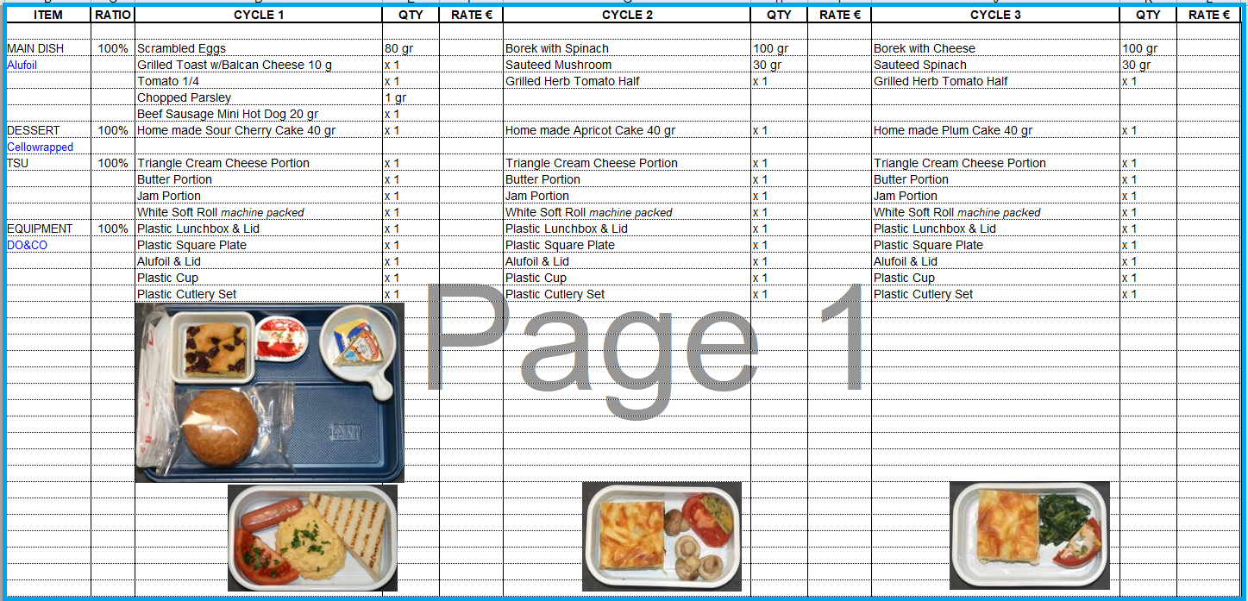
MENU GRID NO 3 / BUSINESS & CREW HOT BREAKFAST/ BC & CR:
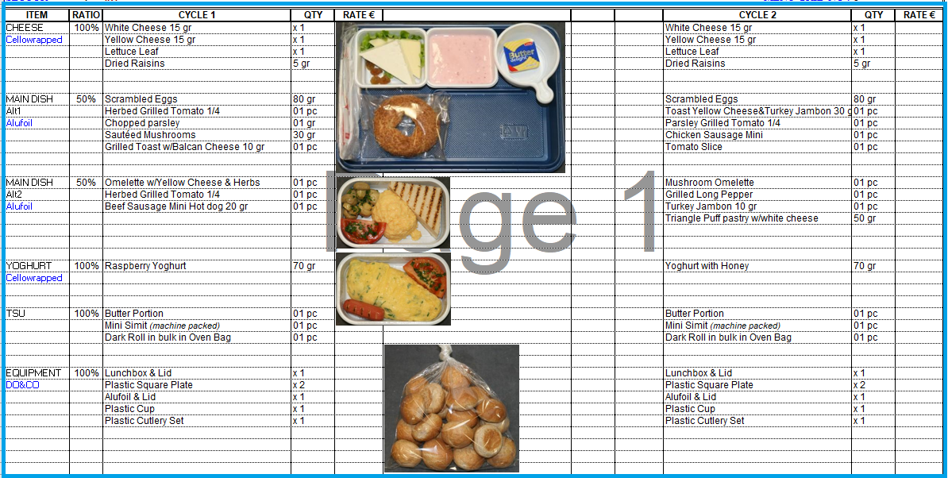

MENU GRID NO :4 / ECONOMY HOT MEALS
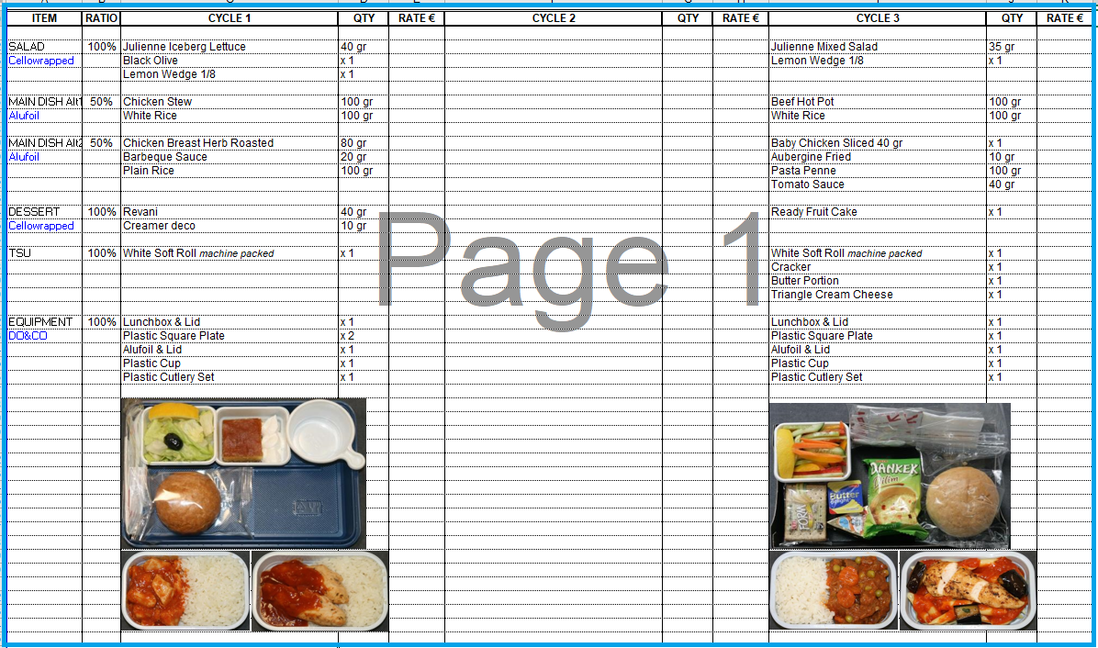

MENU GRID NO: 5/ BUSINESS & CREW HOT MEALS:
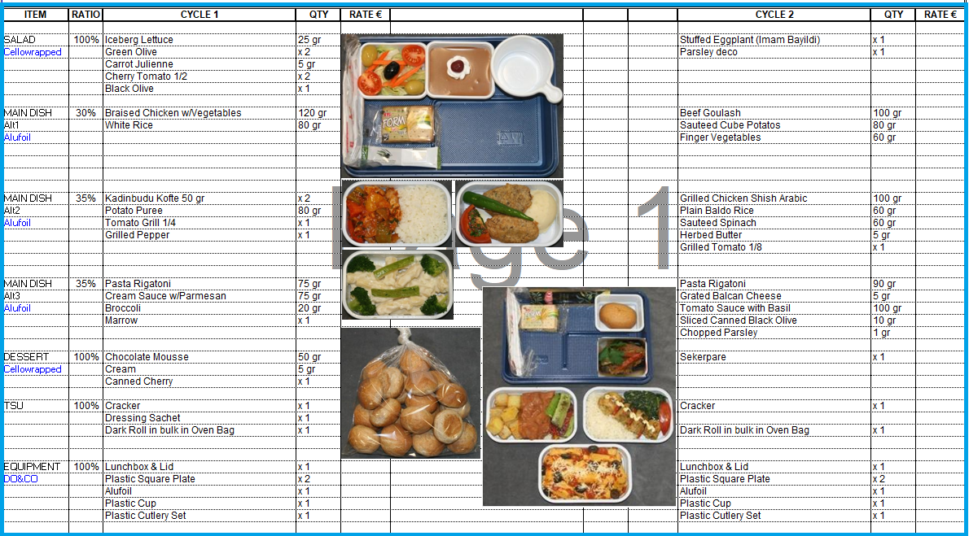
MENU GRID NO: 6 / BUSINESS & CREW HOT MEALS
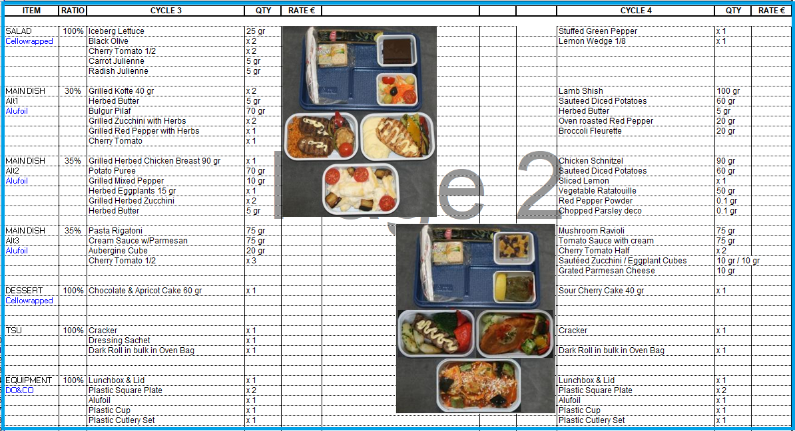

MENU GRID NO: 7 / PAX & CREW SANDWICH
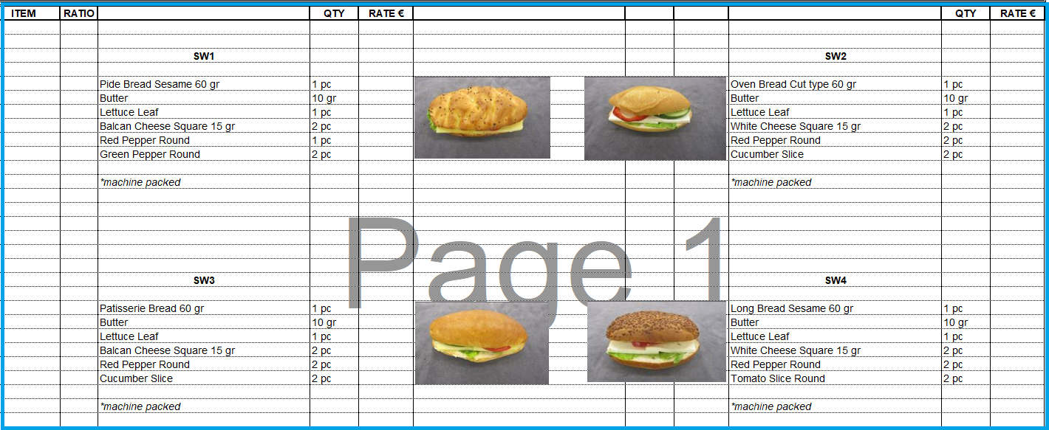

MENU GRID NO: 8 / ANCILLARY ITEMS & EQUIPMENT LIST
S/N |  | DESCRIPTION | QTY/SIZE | RATE € |  |  | S/N | DESCRIPTION | QTY/SIZE | RATE €
 |  | ANCILLARY ITEMS |  |  |  |  |  | EQUIPMENT
SG000015/SG000046 |  | Cola/Fanta (Pet bottle) | 1 lt
SG000016/SG000047 |  | Cola/Fanta (Can) | 33 cl |  |  |  | NF000024 | Carton Box | x 1
SG000225/SG000232 |  | Fruit Juice (Apple,Orange) | 200 ml |  |  |  | NF000340 | Plastic Stirring Spoon | 1 pc
SG000235/SG000237 |  | Fruit Juice (Peach,Cherry) | 200 ml |  |  |  | NF000009 | Plastic Cup | x 1
SG000226/SG000231 |  | Fruit Juice (Apple,Orange) | 1 lt |  |  |  | NF000003 | Cristal Glass | 1 pc
SG000234/SG000236 |  | Fruit Juice (Peach,Cherry) | 1 lt |  |  |  | NF000058 | Napkin 100 pcs | x 1
SG000224 |  | Tomato Juice | 1 lt |  |  |  | NF000045 | Kleenex Box | x 1
TDC00160 |  | Pure Orange Juice | 1 lt |  |  |  | NF000122 | Toilet Roll | x 1
SG000271 |  | Milk (Tetrapak) | 200 ml |  |  |  | NF000014 | Paper Roll | x 1
SG000796 |  | Milk (Tetrapak) | 1 lt |  |  |  | NF000341 | Cologne | x 1
SG000719 |  | Water | 1.5 lt |  |  |  | NF000133 | Ernet/Air Freshener (Solid) | x 1
TDC00194 |  | Hot Water (Thermos) | x 1 |  |  |  | NF000052 | Air Freshener (Spray) | x 1
SG000344 |  | Soda Water (Can) | 33 cl |  |  |  | NF000072 | Soap | x 1
SG000008 |  | Beer (Can) | 33 cl |  |  |  | NF000109 | Garbage Bag | x 1
SG000154/SG000592 |  | Wine Red/White | 18.5 cc
SG000135/SG000155 |  | Wine Red/White | 70 cc
TDC00197 |  | Ice Cubes | 1 kg
NF000139 |  | Dry Ice | 1 kg
SG000022 |  | Sachet Tea | 1 pc
SG000217 |  | Sachet Cream | 1 pc |  |  |  |  | TRAY SET ITEMS
SG000255 |  | Sachet Sugar | 1 pc |  |  |  | SG000818 | Honey (20 gr) | x 1
SG000202 |  | Nescafe Classic Ekopaket | 100 gr |  |  |  | SG000280 | Yoghurt | x 1
SG000198 |  | Nescafe Gold Ekopaket | 100 gr |  |  |  | SG000805 | Mini Chocolate | x 1
TDC00215 |  | Lemon Whole | x 1 |  |  |  | SG000803 | Cracker | x 1
TDC00212 |  | Lemon Sliced | x 1
TDC00298 |  | Roll Bread | x 1

  - On this Agreement Date, First Party shall provide (2) copies of the Standard Menu list including prices and (2) copies of the rotating Crew Meals Menu list including prices.
  - Second Party shall provide the First Party suggested menus, proper portion sizes with color photographs if any. The First Party will provide the prices for suggested menus to the Second Party for Approval.
  - The First Party shall have the right to adjust individual cost of components but as a result of changes in cost of products purchased by the caterer, provided that the intended change has been submitted in writing by the First Party to the Second Party prior to the requested date of effectiveness and that the change in cost is of an unforeseen nature and occurs due to uncontrollable factors such as:
- Price Changes by Suppliers
- Substantial cost increase
- Gov's fees and taxes
- Expected inflationary trends.
- Catering Orders and Cancellation Policy
  - The Second Party must place a provisional order at least Twelve hours before the expected time of Delivery in order to enable the First Party to start preparation and delivery the required order well on time.
  - Cancellation of Meals and Refreshments order made by the Second Party will be accepted and chargeable by the First Party based on following conditions:
- Less than Four hours from given time of Delivery - 100% Charge of all perishable items.
- Less than Six hours from given time of Delivery - 50% Charge of all perishable items.
- Eight hours before given time of Delivery - No Charge of all perishable items

- Delivery
  - The First Party will deliver and make available the Meals and Beverages ordered at a place mutually agreed between the two Parties.
  - The first part will charge the handling service in the catering invoices as per aircraft type.

- Invoicing and payment

  - The First Party will invoice the Second Party on each flight for the Meals and Beverages provided to the Second Party’s Passengers/Crew. And the invoices will be sent monthly and full settlement of invoice within 30 calendar days upon issuance of invoice. A late fee of 1% per month will be charged for any late payment
- Service credits
  - If at any time the first party cannot meet the goals of the service level, the first party must pay the difference between the price of services and goods according to the invoice of the seller (Second Catering provider) to Ariana.
- Insurance
  - First Party shall maintain at all times during the term of this Agreement, a Comprehensive General Liability insurance against Bodily Injury or Property Damage, including products completed operations liability and aircraft in an amount of USD.50 million for each occurrence.
  - First Party shall provide insurance certificate evidencing the provisions in addition to 30 days’ notice of cancellation, non-renewal or material change in coverage. This certificate shall be submitted to the Second party at the following address:
- Liability and Indemnity
  - The Carrier shall not make any claim against the Caterer and shall indemnify it (subject as hereinafter provided) against any legal liability for claims or suits, including costs and expenses incidental thereto, in respect of:
a. delay, injury or death of persons carried or to be carried by the Carrier; and
b. injury or death of any employee of the Carrier; and
c. delays of baggage, cargo or mail carried or to be carried by the Carrier; and
d. damage to or loss of property owned or operated by or on behalf of the Carrier and any consequential loss or damage;
arising from an act or omission of the Caterer in the performance of this Agreement unless done with intent to cause damage, death, delay, injury or loss or recklessly and with the knowledge that damage, death, delay, injury or loss would probably result.
PROVIDED THAT all claims or suits arising hereunder shall be dealt with by the Carrier;
and
PROVIDED ALSO THAT the Caterer shall notify the Carrier of any claims or suits without undue delay and shall furnish such assistance as the Carrier may reasonably require.
  - Notwithstanding the provisions of sub - article 7.1 above the Carrier shall be entitled to make such claims as it sees fit against the Caterer, and the Caterer shall indemnify the Carrier against any legal liability for claims or suits including costs and expenses incidental
thereto, in respect of:

a. death, injury, illness or disease of person carried by the Carrier; and
b. death, injury, illness, or disease of any employee of the Carrier;
arising from the caterer's failure to comply with the following

i) ensure that all premises, plant, production, processes, utensils and vessels used for storage, preparation, production and transportation of all meals and beverages provided to the Carrier's aircraft meet the standards of hygiene specified by all applicable local and international laws, regulations, procedures and requirements.

ii) take all reasonable steps to ensure that food and water delivered to the Carrier's aircraft and utensils or vessels used for the provision of the Services required by the Carrier shall be free from both living organisms of disease and toxic substances of any origin to the extent required by all applicable local and international laws, regulations, procedures and requirements.
  - The Carrier shall not make any claim against the Caterer in respect of damage, death, delay, injury or loss to third parties (being parties other than the Carrier and Caterer and other than persons carried or to be carried by Carrier) arising from an act or omission of the Caterer in the performance of this Agreement unless done with delay, injury or loss would probably result.
  - a- Notwithstanding the provision of Sub - Article 7.1, in the case of claims arising out of surface transportation which is provided in the execution of this Agreement and is part of the operation of loading or unloading and/or is covered by the Carrier's contract of carriage the indemnity shall not exceed the limits specified in the said contract of carriage.
  - b- in the case of claims arising out of surface transportation which is NOT provided on behalf of the Carrier and/or is NOT part of the operation of loading or unloading and / or is NOT covered by the Carrier's Contract of Carriage the waiver and indemnity herein contained shall not apply.
  - The Caterer shall not make any claim against the Carrier and shall indemnify it (subject as hereinafter provided) against any legal liability for claims or suits, including costs and expenses incidental thereto, in respect of:
a. Injury to or death of employees of the Caterer, its servants, its agents or its subcontractors; and
b. damage to or loss of property owned or operated by or on behalf of the Caterer and any consequential loss or damage:
arising from an act or omission of the Carrier in the performance of the Agreement unless done with intent to cause damage, death, delay, injury or loss or recklessly and with knowledge that damage, delay, injury or loss would probably result.
  - Without prejudice to its liability to indemnify the Carrier, the Caterer shall maintain at its own expense such insurance's as are necessary to cover its liabilities and obligations arising under this Agreement and in particular under Sub Article 7.2 for the amount of and upon the terms specified in the relevant Annexes hereto.
- Non-disclosure
  - The Second Party fully understands and agrees that the information, date and documents (the "Information"), that may be furnished or made available to him or derived during the term of this Agreement are of confidential nature.
  - The Second Party agrees that such Information shall neither be permitted out of its possession, nor divulged to any person, firm or corporation.
  - Any disclosure of the said information in the public domain through improper channels by Second Party will be the responsibility of the Second Party and shall constitute an immediate cause for termination of this Agreement.
- Amendments
  - This Agreement may be amended or varied only by an instrument in writing executed by the Parties hereto or their respective assigns.
- Ordering Procedure
  - All Catering Orders and other communications under this agreement shall be in writing and in the English Language and either delivered by hand or sent by email, Telex, Facsimile Courier or registered Mail in each case to the address, email, Sita Telex, Facsimile number of the relevant party specified (or any other address, telex, facsimile number as either party may notify the other time to time) and shall be considered served and received.
  - Preliminary ordering of meals will be made by the Second Party not less than 8 hours before scheduled departure.
  - Second Party agrees to inform the First Party as early as possible of cancellations and/or additions of uplifts and services.
  - In case of shorter notice of additional meals be possible when given not less than two hours’ notice prior to departure.
- Terms and Termination
  - The termination of the Agreement shall not release either Party from any liability, obligation, or agreement, which pursuant to any provision of the Agreement, has to survive or be performed after such termination.
  - The Agreement shall commence on the mutually Date and shall continue in force for 1 years and will be extended for another 1 year based on Ariana evaluation committee positive report. This evaluation process will continue for 3 years thereafter if evaluation committee report found positive then it will renew automatically for another (1) year or until it is terminated in accordance with the Agreement.
  - Without prejudice to its other rights pursuant to law and this Agreement, if a Party is in material breach of one of its obligations under this Agreement, the other Party will have the right to terminate the Agreement by sending the other Party written notification via registered mail of any such breach, with the express invitation to remedy such breach within 7 (seven) days of the date of receipt of the same notice. If such Party fails to remedy the material breach within such term, the Agreement shall be terminated.
  - To the extent permitted by the applicable law, either Party may by written notice to the other Party immediately terminate this Agreement where the other Party ceases to carry on business, is unable to pay its debts when they fall due, is declared bankrupt, or an order is made or a resolution passed for the winding up of that other Party or the appointment of an administrator, receiver, liquidator or manager of that other Party.
  - Either Party may terminate without cause the Agreement upon one month written notice to the other Party sent via registered mail].
- Non-waiver
  - The failure of either Party to enforce, at any time, any provision of the Agreement or to require, at any time, the enforcement of any provision of the Agreement shall in no event be construed to be a present or future waiver of such provision.
  - The express waiver by either Party of any provision condition of this Agreement shall not constitute a waiver of any future obligation to comply with such provision or condition.
- Assignment
  - The Second Party shall not appoint any other person, Company or Organization to provide the services that the First Party has agreed to provide by virtue of this agreement.
- Governing Law and disputes
  - This agreement shall be construed, interpreted in accordance with the Laws of Turkey.
  - Any dispute, controversy or claim arising out of or in connection with the Agreement or any breach or invalidity thereof shall be amicably settled within 15 days from the date of dispute, but failing which shall be finally settled by 90 days.
- Force majeure:
  - Force Majeure event for the purposes of this Agreement means any cause not reasonably within the control of the parties, including such causes as labour disputes, strikes, governmental intervention, or the party’s response to the insistence of any governmental instrumentality or person purporting to act therefore, terrorism, wars, civil commotion, hijacking, fire, flood, accident, storm or any act of God.

  - If a Force Majeure Event occurs which prevents a Party (the "Affected Party") performing any of its obligations hereunder or causes a delay in performance, the Affected Party shall not be liable to the other Party and shall be released from its obligation to fulfil its obligations under this Agreement to the extent that its ability to fulfil such obligations has been directly affected by the Force Majeure Event, provided that:
  - The Affected Party notifies the other Party in writing as soon as reasonably practicable of the occurrence of the Force Majeure Event and the nature and likely duration of its impact upon the other Party;
  - the Affected Party takes all reasonable steps to mitigate the impact of the Force Majeure Event on the other Party, and in particular continues to perform those obligations affected by the Force Majeure Event but whose performance has not been rendered impossible to the highest standard reasonably practicable in the circumstances;
  - the Affected Party continues to perform all its obligations which have not been affected by the Force Majeure Event; and
  - the Affected Party resumes normal performance of all affected obligations as soon as the impact of the Force Majeure Event ceases, and notifies the other Party in writing promptly of such resumption.
  - If the impact of the Force Majeure Event upon the Affected Party continues for a period of no less than [30] consecutive days the Affected Party may, without incurring liability, terminate this Agreement either in whole or in part with immediate effect by providing written notice to other Party, without having to file a claim with the competent Court to that effect.
- Suspension of services:
  - The First Party may suspend the provision of the Services, by giving the Ariana no less than 7 (seven) Working Days' notice, in circumstances where it is necessary for the First Party without disturbing the ongoing operations of Ariana. The First Party shall, in its notice, inform the Ariana of the timing, the duration and the reasons for the proposed suspension.
  - The Ariana shall be entitled to request in writing a postponement of the suspension. The First Party shall not unreasonably deny its consent to the above request of the Ariana. Without limitations, the First Party may reject the postponement if it is not feasible for technical reasons.
- Disputes – jurisdiction:
  - Without prejudice of Section 21.2, if any dispute should arise between the Parties relating to or deriving from this Service Agreement, it may be settled in the first instance in accordance with the following procedure:

  - when a dispute arises, one Party may request the other in writing to start the settlement procedure;
  - the Parties undertake to appoint their own representative, holding suitable powers, selected from persons who are not directly involved in the performance or management of this services Agreement and the corresponding activities; the said Parties’ representatives shall meet with the aim of settling the dispute amicably, having regard above all to the primary need to maintain the continuity of the Services forming the subject of this services Agreement;

  - if, after making all reasonable attempts at a settlement, the said representatives are unable to settle the dispute within 30 (thirty) working days of the date of the request to initiate the settlement procedure. The matter is processed in accordance with Article 22-4 of this document.
  - The procedure of Section 21.1 shall not prevent either Party from taking such action as it deems appropriate (including any application to a relevant court) for injunctive or other emergency or interim relief.
  - The Parties irrevocably agree that the Court of [to be provided] shall have exclusive jurisdiction to settle any dispute or claim that arises out of or in connection with this services Agreement or its subject matter or formation (including non-contractual disputes or claims). In case the Ariana is a consumer, the above choice of the competent court shall apply to the extent admitted by the applicable law which will be discussed during finalization of contract with First Party. OR
  - Any dispute between the parties shall be resolved under international chamber of commerce- Amicable dispute resolution (ICC ADR) Rules, failing which the parties shall try to resolve these differences through ICC Arbitration which should not be in conflict with the laws of Afghanistan.

- Integrity Pact:
23-1- The bidder is obliged to read and sign the appendix number two of this contract. The mentioned document is a covenant and approval from the bidder (First Party) who has not obtained and / or not promoted the services through any corrupt business method and will not do so in the future.

Annex (I) Form of Bid

Date --/--/2021
Ref: RFQ 004-052-Flight Catering

To: Ariana Afghan Airlines

Dear Sir,
Having examined the RFQ, we, the undersigned, offer for (RFQ 004-052) in full conformity with the said Bidding Documents against the terms and conditions mentioned above in this RFQ.

No | Menu | Descriptions | AAA/S/N | UOM | QTY | UNIT PRICE €
1 | Menu Grid2 | YC HOT BREAKFAST CYCLE 1 | AFG00001 | Box | 1
 |  | YC HOT BREAKFAST CYCLE 2 | AFG00002 | Box | 1
 |  | YC HOT BREAKFAST CYCLE 3 | AFG00003 | Box | 1
2 | Menu Grid3 | BC & CR HOT BREAKFAST CYCLE 1 | AFG00004 | Box | 1
 |  | BC & CR HOT BREAKFAST CYCLE 2 | AFG00005 | Box | 1
3 | Menu Grid4 | YC HOT MEAL 1 | AFG00006 | Box | 1
 |  | YC HOT MEAL 2 | AFG00007 | Box | 1
4 | Menu Grid5 | BC & CR HOT MEAL CYCLE1 | AFG00010 | Box | 1
 |  | BC & CR HOT MEAL CYCLE2 | AFG00011 | Box | 1
5 | Menu Grid6 | BC & CR HOT MEAL CYCLE3 | AFG00012 | Box | 1
 |  | BC & CR HOT MEAL CYCLE4 | AFG00013 | Box | 1
6 | Menu Grid7 | PAX & CREW SANDWICH1 | AFG00017 | Box | 1
 |  | PAX & CREW SANDWICH2 | AFG00018 | Box | 1
 |  | PAX & CREW SANDWICH3 | AFG00019 | Box | 1
 |  | PAX & CREW SANDWICH4 | AFG00020 | Box | 1

S/N |  |  | DESCRIPTION | QTY/SIZE | RATE € |  |  |  | S/N |  | DESCRIPTION | QTY/SIZE | RATE €
Menu Grid8
 |  |  | ANCILLARY ITEMS |  |  |  |  |  |  |  | EQUIPMENT
SG000015/SG000046 |  |  | Cola/Fanta (Pet bottle) | 1 lt
SG000016/SG000047 |  |  | Cola/Fanta (Can) | 33 cl |  |  |  |  | NF000024 |  | Carton Box | x 1
SG000225/SG000232 |  |  | Fruit Juice (Apple,Orange) | 200 ml |  |  |  |  | NF000340 |  | Plastic Stirring Spoon | 1 pc
SG000235/SG000237 |  |  | Fruit Juice (Peach,Cherry) | 200 ml |  |  |  |  | NF000009 |  | Plastic Cup | x 1
SG000226/SG000231 |  |  | Fruit Juice (Apple,Orange) | 1 lt |  |  |  |  | NF000003 |  | Cristal Glass | 1 pc
SG000234/SG000236 |  |  | Fruit Juice (Peach,Cherry) | 1 lt |  |  |  |  | NF000058 |  | Napkin 100 pcs | x 1
SG000224 |  |  | Tomato Juice | 1 lt |  |  |  |  | NF000045 |  | Kleenex Box | x 1
TDC00160 |  |  | Pure Orange Juice | 1 lt |  |  |  |  | NF000122 |  | Toilet Roll | x 1
SG000271 |  |  | Milk (Tetrapak) | 200 ml |  |  |  |  | NF000014 |  | Paper Roll | x 1
SG000796 |  |  | Milk (Tetrapak) | 1 lt |  |  |  |  | NF000341 |  | Cologne | x 1
SG000719 |  |  | Water | 1.5 lt |  |  |  |  | NF000133 |  | Ernet/Air Freshener (Solid) | x 1
TDC00194 |  |  | Hot Water (Thermos) | x 1 |  |  |  |  | NF000052 |  | Air Freshener (Spray) | x 1
SG000344 |  |  | Soda Water (Can) | 33 cl |  |  |  |  | NF000072 |  | Soap | x 1
SG000008 |  |  | Beer (Can) | 33 cl |  |  |  |  | NF000109 |  | Garbage Bag | x 1
SG000154/SG000592 |  |  | Wine Red/White | 18.5 cc
SG000135/SG000155 |  |  | Wine Red/White | 70 cc
TDC00197 |  |  | Ice Cubes | 1 kg
NF000139 |  |  | Dry Ice | 1 kg
SG000022 |  |  | Sachet Tea | 1 pc
SG000217 |  |  | Sachet Cream | 1 pc |  |  |  |  |  |  | TRAY SET ITEMS
SG000255 |  |  | Sachet Sugar | 1 pc |  |  |  |  | SG000818 |  | Honey (20 gr) | x 1
SG000202 |  |  | Nescafe Classic Ekopaket | 100 gr |  |  |  |  | SG000280 |  | Yoghurt | x 1
SG000198 |  |  | Nescafe Gold Ekopaket | 100 gr |  |  |  |  | SG000805 |  | Mini Chocolate | x 1
TDC00215 |  |  | Lemon Whole | x 1 |  |  |  |  | SG000803 |  | Cracker | x 1
TDC00212 |  |  | Lemon Sliced | x 1
TDC00298 |  |  | Roll Bread | x 1
HANDLING CHARGE - May 2021
S.No. | Details |  |  |  |  |  | Unit |  |  | Qty | Amount
1 | HANDLING CHARGE |  |  |  |  |  | FLT |  |  | 1

We undertake, if invited to do so, and at our own cost, to attend a clarification meeting at a place of your choice OR attend a conference call at a Time of your choice, furthermore.
We agree to abide by this Bid, for a period of (45) days from the date fixed for submission of undertakings, it shall remain binding on us.
We also undertake, if our bid is accepted, to make implementation of above-mentioned services as per the dates mentioned in our bid.
Until a formal contract is prepared and executed between us, this bid, together with your written award letter thereof and your notification of award shall constitute a binding contract between us.
We understand that you are not bound to accept the lowest or any bid you may receive.

----------------------------------------------
Signature of Authorized Person
Name: -------------------------------------------
Position: ----------------------------------------
Office Seal ----------------------------------------
Dated This ----------------------- day of --------------------2021

Annex (II)

Integrity Pacts:
{Name of bidder (Service Provider)} hereby declares its intention not to obtain or induce the procurement of any contract, right, interest, privilege or other obligation or benefits from government of Afghanistan or any administrative subdivision or agency thereof or any other entity owned or controlled by it through any corrupt business practice.
Without limiting the generality of the foregoing, {Name of bidder (Service Provider) } represents and warrants that it has fully declared the brokerage, commission, fee etc. paid or payable to anyone and not given or agreed to give to anyone within or outside Afghanistan either directly or indirectly through any natural or juridical person, including its affiliate, representative, associate, broker, consultant, director, promoter, shareholder, sponsor or subsidiary, any commission, gratification, bribe, finder’s fee or kickback, whether described as consultation fee or otherwise, with the object of object of obtaining or including the procurement of a contract, right, interest, privilege or other obligation or benefit in whatsoever form from government of Afghanistan, except that which has been expressly declared pursuant hereto.
{Name of bidder (Service Provider) } Certifies that it has made and will make full discloser of all agreements and arrangements with all persons in respect of or related to the transaction with Government of Afghanistan and has not taken any action or will not take any action to circumvent the above declaration, representation or warranty.
{ Name of bidder (Service Provider) } accepts full responsibility and strict liability for making any false declaration, not making full disclosure, misrepresenting facts or taking any action likely to defeat the purpose of this declaration, representation and warranty. It agrees any contract, right, interest, privilege or other obligation or benefit obtained or procured as aforesaid shall, without prejudice to any other right and remedies available to Government of Afghanistan under any law, contract or other instrument, be voidable at the option of Government of Afghanistan.
Notwithstanding any rights and remedies exercised by Government of Afghanistan in this regard, (Name of bidder (Service Provider) } agrees to indemnify Government of Afghanistan for any loss or damage incurred by it on account of its corrupt business practices and further pay compensation to Government of Afghanistan in an amount equivalent to ten time the sum of any commission, gratification bribe, Finder’s fee or kickback given by { Name of bidder (Service Provider) } as aforesaid for the purpose of obtaining or inducing the procurement of any contract, right, interest, privilege or other obligation or benefit in whatsoever form from Government of Afghanistan.

Signature of the Bidder (Service Provider) …………………………………………………….

{Name, Title and address)

Official Seal ……………………………….

ANNEX – (III)

Bidder (Service Provider) Profile
Bidder (Service Provider) (S) Should provide the following detail their company letter heads
Name of the company
Head Office address
Local office address (If any)
Contact / Focal Person
Name:
Designation:
Telephone:
Fax:
Email:
Type of the Company: | Public | Privet | Other
Company Ownership proof
(Derail of major shareholder of company)
List of Customer:
(List of customers should be attached herewith)
Financial Health:
(Provide Summary of Last Three years Annual Reports)

Signature: …………………………… Title ………………………………………….

Name ………………………………….. Date ………………………………………….

Company stamp

