Standard Bidding Documents
(SBD)
FOR REPAIR OF CF6-80C2A2 Engine

ARIANA AFGHAN AIRLINES

Document Name | Standard Bidding Documents (SBD)
Description | Repair of Aircraft CF6-80C2A2 Engine
SBD Number | 004-283-Supply
SBD Announcement Date | 30-Nov-2021
SBD Closing Date | 11-Dec-2021
SBD Closing Time | 09: 00 AM Kabul Time

Contents
A- PREFACE: 3
1. Part A: KNOW YOUR CUSTOMER (KYC): 3
Important Notice: 3
B- GENERAL TERMS AND CONDITIONS 4
1- Definitions: 4
2. General 5
3. Ordering procedure: 6
4. Delivery: 6
5- Payment Terms: 7
6- Cancellation of orders: 7
7- Taxes, duties and other charges: 7
8- Assignments: 8
9- Non-disclosure: 8
10- Excusable delay: 8
11- Suspension and termination: 8
12- Applicable law and arbitration: 8
13- Indemnity: 9
14- Export control: 9
C- CONDITIONS FOR COM(RO) NENT REPAIR AND OVERHAUL 9
1- Component repair and overhaul: 9
1-1. Repair Ordering procedures. 9
1-2. Repair Order Acknowledgement. 9
1-3. Repair Order fulfillment. 10
1-4. Sub contract. 10
1-5. Modification standard. 10
1-6. Beyond Economic al Re pair (BER). 10
1-7. Shop Finding Report. 10
1-8. Investigation Report Seller is prepared, at Buyer’s request, 10
1-9. Delivery to Seller: 11
1-10. Delivery to Buyer: 11
1-12. Certification: 11
1-13. Release Certificate (CRS) or similar document issued by a duly authorized person. 11
1-14. Risk of repaired and/or overhauled Components: 11
The risk of loss of the Components send to Seller shall at all times remain with Buyer. 11
1-15. Warranty conditions for repaired and/or overhauled Components: 11
1-16- Exceptions. 11
D. TECHNICAL CRITERIA, SCHEDULE OF ITEMS AND PRICED QUOTATION: 12
Engine Current LLP Record 13
E. DOCUMENTATION REQUIRED WITH THE SUBMISSION OF THE QUOTATION 13
F. QUOTATIONS VALUATION, EXAMINATION AND DETERMINATION OF RESPONSIVENESS. 13
G- Model CF6-80C2A2 Engine ESN 695-402 Bore Scope Inspection result 15
Authorization: 16

- PREFACE:

Part A: KNOW YOUR CUSTOMER (KYC):
Ariana Afghan Airlines was established in January 1955. In 1957 an agreement was negotiated between the Royal Afghan Government and the United States International Co-Operation Administration (ICA) to create a partnership with a leading American airline company PanAm's and continued it until 1978. Now Ariana is 100% afghan government Airline and operating B737/CL and A310 Aircraft. An interesting footnote to that event was that the Shah of Afghanistan personally designed the logo for Ariana Afghan Airlines, the very same logo that is still proudly retained.

Important Notice:
- Ariana Afghan Airlines request from all vendors to carefully review the terms and condition of this SBD and sign and stamp the SBD . Because Signing of the SBD grants the evaluation of the offer,
- The SBD which not signed by the vendor will not process and will be reject and consider as irresponsive quotation.
- The quotation shall be completed and signed by an authorised representative of the Supplier.
- In the case of any arithmetical discrepancy between the Unit Rate and the Total Amount quoted, then the Unit Rate shall prevail both for the evaluation of quotations and for the subsequent Repair Order .
- Depending on the final requirement, the quantities shown may increase or decrease by twenty five percent (25%) and this shall be reflected in the Repair Order.
- The Purchaser is not bound to accept the lowest quotation and reserves the right to accept or reject any or all the quotations without assigning any reason whatsoever.
- The official email address for submitting of quotation is quotation-box@flyariana.com and quotation must be sent only to this email address before closing date.
- This Standard Bidding Documents (“SBD”) shall govern the provision of services, sale / Purchase of goods, and any other activities performed (collectively the “Services”) by Seller to Buyer.

- GENERAL TERMS AND CONDITIONS

Definitions:
The following definitions shall apply (such definitions to be equally applicable to both singular and plural forms of the terms to be defined):
Aircraft: an aircraft owned or operated by Buyer;
- Agreement: By sending of the Repair order to the vendor, the Repair order and dually signed SBD together will be considered as annex Number one of the Engine Repair Agreement and automatically take on the status of an Annex to the contract and the parties are required to comply with it. In the event of a dispute between the contract and SBD, the terms of the SBD shall take precedence over the terms of the contract
- Parties: Vendor which sent signed and stamped Ariana SBD, and Ariana Afghan Airlines are called parties.
- BER: a component of which the repair/overhaul value exceeds the replacement cost of a unit in serviceable or overhauled conditions, as set forth in article 1-6 of part C;
- Buyer: the party to whom Seller provides Services;
- Seller: the party whom Repair the Engine, Landing Gear, APU, Tools , Component, LRU and other parts accordance to the Aviation standard to the buyer:
- Component: any self-contained part, combination of parts, sub-assemblies or units, which perform a distinctive function necessary to the operation of a system;
- Core Unit: a part of an aircraft which must be replaced.
- Data: documents, drawings, manuals, computer programming information, software and all other forms of media storing, containing, conveying or embodying information, and regardless of whether the information is in hard copy, electronic, or any other form;
- Ex-works: Ex-works as defined in the incoterms 2011 or any subsequent edition thereof, issued by the International Chamber of Commerce, Paris, France;
- SBD: Shall have the meaning as (Standard Bidding Documents);
- Indemnities: Seller and Seller's Assignees and their respective directors, shareholders, affiliates, officers, employees, agents, representatives and subcontractors; Buyer and Buyers Assignees and their respective directors, shareholders, affiliates, officers, employees, agents, representatives and subcontractors;
- Information: all (technical) Data pertaining to Services, whether or not established by Seller and Buyer to be confidential, or copies of any of these supplied by Seller under this SBD;
- Inspection Period: the (15) calendar day period after receipt by Buyer of any Spare Parts ordered by Buyer;
- Investigation Report: a report, which mentions the possible cause of a malfunction and observed damage of a component and provides details of repair shop findings with regard to rectification of said malfunction or sampling requirements;
- Order Acknowledgement: acceptance by Seller of Buyer's (Repair) Order(s) in the system OR writing;
- Overhaul (OH):the restoration of the Component according to the agreement pertaining to this
SBD , in accordance with the instructions defined in the relevant manual.
- Repair Order (RO): an order for Spare Parts Test, Repair or overhaul placed by Buyer in writing (or by e-mail, facsimile or any other (written) instrument);
- Repair (SV):the test and restoration, if applicable, of a defective Component and/or Aircraft, whichever is applicable according to the agreement pertaining to this SBD , to a serviceable condition only;
- Seller's Assignee: any person(s) or company (companies) used or assigned by Seller, either as a subcontractor or supplier, to perform Services, under the repair order or supplying Seller Parts or information pertaining thereto to Seller for the performance of Services by Seller under the SBD and related repair order ;
- Seller's Facility: such plant or facility as may be designated by Seller, as set forth in article 4.1 of Part B;
- Seller Parts: Components, systems, accessories, equipment and parts, including ground support equipment and special tools for the Aircraft supplied in accordance to Buyer's specifications, delivered from Seller's own stock.
- Services: shall have the meaning as defined in the preface of this SBD;
- Shop-Finding report: a report which provides information on basic observations made during testing, repair and/or overhaul of the Component;
- Parts: such aircraft parts, Engine , APU , Landing Gear that may be Test, Repair, overhaul and to be delivered by Seller to Buyer;
- Vendor: any manufacturer, MRO, Repair shop or supplier;
- Vendor Parts: mean aircraft components, systems, accessory, equipment and parts, including ground support equipment and special tools for the aircraft not covered by the definition of Seller Parts.
- General
  - General. Any of the services Seller agrees to provide to Buyer shall be subject to this SBD and such additional terms and conditions as agreed upon by Seller and Buyer in writing. In addition, these SBD shall apply to all agreements, quotation(s) or order acknowledgment(s) entered into by Seller with respect to Services to be rendered, unless otherwise expressly stated by Seller in relevant quotation or agreement. The applicability of any general terms and conditions which may be used by Seller / Buyer or to which Seller / Buyer may refer in any manner whatsoever is hereby specifically rejected.
  - Notices. Unless agreed upon otherwise in the SBD or any agreement pertaining thereto, all notices and requests in connection with the SBD and related (RO) shall be given in writing and may be given by e-mail or any other customary means of (written) communication addressed as follows: techsupply@flyariana.com
  - The effective date of any notice or request given in connection with the SBD or any agreement pertaining thereto, shall be the date on which the notice or request is received by Seller / Buyer and/or sent by Seller/ Buyer.
  - English language. The performance of Services and all communication between Seller and Buyer regarding this SBD and related (RO) or any agreement pertaining thereto shall be in writing in the English language.
  - Compliance: Buyer / seller shall comply, and is in compliance with, all applicable laws, rules and Regulations and judgments and/or orders of competent courts of jurisdiction or relevant (governmental) authorities. The parties accept as a joint responsibility that the agreement pertaining to the SBD shall ensure consistency with all requirements and obligations in effect, pursuant to the aforesaid regulations, including required procedures and routines.
- Ordering procedure:
  - Upon Buyer's request, Seller shall make price and schedule quotations for Services before closing date and quotations shall be valid for a period of thirty (30) calendar days after the date of issue, unless otherwise stipulated in the relevant quotation. The Services shall only be rendered by Seller on the basis of Repair order (RO) issued by Buyer which is accepted by Seller in (writing), unless Buyer and Seller have agreed in writing to an alternative procedure.
- Delivery:
  - All goods and Services furnished under this SBD shall be delivered Ex-works Seller's Facility, unless otherwise specified by Seller but the seller facility address should be mentioned in the schedule of price.
  - Packing: all goods service furnished and under this SBD shall be packed in accordance with manufacturer recommendation and standard acceptable practices. If necessary Containers or equivalents equipment’s, shall be used and the additional costs involved shall be for Buyer's account.
  - Shipment. All goods and/or Services furnished under this SBD shall be accompanied by packing documents indicating Buyer's Repair Order number, quantity shipped, part number (where applicable), key word and total value. Seller shall inform Buyer, as soon as practicable, about shipping arrangements made.
  - Buyer’s Responsibility. Buyer shall be responsible to ensure the timely and continuous availability validity, completeness, reliability and accuracy of any and all Data and goods, Buyer is reasonably required to provide for the due performance of the Services by the Seller. Inspection by Seller of Buyer furnished items shall not relieve Buyer from its responsibility hereunder.
  - Seller Responsibility. Seller shall be responsible to provide the standard (test, repair or overhaul) of the parts in agreed TAT as well as airworthy condition services .The seller is also obliged to provide a standard warranty for the repair of repaired parts with all required technical data.
  - Retention of title. All Seller Parts, Components, Spare Parts or any other goods delivered by Seller shall remain property of Seller until full payment thereof has been received by Seller from Buyer, and no payments are due by Buyer to Seller with respect to previous delivery of Seller Parts, Components, Spare Parts or any other goods.

- Payment Terms:
  - On credit basis:
Payment of the Service with the amount of USD 49999 will be processed on credit basis and the invoice shall be due and payable within thirty (30) calendar days of the date of delivery of the service from the Seller to Buyer. The seller is responsible to deliver the shipment to the forwarder and there is no need for the request of advance payment at this stage.
  - On bank guaranty Basis:
Payment of the Service with the amount of 50000 or above will be processed on advance but it will be paid against the equal bank guarantee OR MRO guaranty letter and Approved work progress report which submitted by Seller to Buyer.
  - Additional costs: If Seller incurs any costs in connection with additional services and/or activities (to be) rendered to Buyer upon Buyer's request, such as freight cost, special packing and other repair cost which were not mentioned in Seller's agreements, quotation(s) or Repair order (RO) acknowledgment(s), Seller shall notify Buyer for obtaining of approval of Buyer. After receipt of the approval of Buyer the seller can complete the tsk and issue the invoice for such a costs of such a Services and Buyer shall pay the costs within thirty (30) calendar days after the date of Seller's relevant invoice In the same payment conditions as mentioned in this SBD .
  - Currency: All payments to Seller shall be made in USD and is specified on (RO) and invoice for credit of Seller's account with a bank to be nominated by Seller, unless agreed upon otherwise in writing.
  - Security: Buyer shall have the right to ask security OR bank guaranty acceptable to Buyer from seller for all sums of requested in advance. Pursuant to article 5-2.
  - Dispute. If Buyer disputes Sellers invoice, Buyer shall notify Seller of this dispute in writing within fourteen (14) calendar days upon the date of Sellers relevant invoice. In such event, Buyer shall only be entitled to suspend payment of the disputed part of the invoice for a maximum of fourteen (14) calendar days. As soon as possible parties will discuss the disputed part of the invoice and make every reasonable effort in order to promptly settle the dispute. In the event parties agree that the dispute is justified, Seller will adapt the invoice and Buyer will subsequently pay outstanding amounts.
- Cancellation of orders:
  - In the event if the seller did not deliver the service in agreed TAT Buyer will cancel the Repair Order for any goods and/or Services and will notify the seller to deliver the Parts on as is condition to the forwarder.
- Taxes, duties and other charges:
  - Taxes. Duties and other charge: Any taxes, duties and other charges of any kind levied by any Afghan government authority in Afghanistan on Services to be rendered by Seller to Buyer and/or on payments to be made by Buyer to Seller shall be for the account of Buyer.
  - Taxes, Duties and other charge. Any taxes, duties and other charges of any kind levied by any authority in the country of seller on Services to be rendered by Seller to Buyer and/or on payments to be made by Buyer to Seller shall be for the account of Seller.
- Assignments:
  - The agreements pertaining to this SBD is for the benefit of and binding upon each of the parties hereto and their respective successors and assignees. Neither Seller nor Buyer may assign any of its rights, obligations or claims under the agreements pertaining to this SBD, without the prior written consent of the other party, which shall not be withheld on unreasonable grounds.
- Non-disclosure:
  - Non-disclosure. Except as required pursuant to mandatory law, neither Buyer nor Seller may disclose to third parties the contents of this SBD and any agreements, quotation(s) or order acknowledgment(s) relating to the Services, or any information provided by a party to another party under circumstances which reasonably indicate that the information is confidential, without the prior written consent of the other party.
- Excusable delay:
  - Seller shall not be responsible for, nor be in default under this SBD on account for any delay in performance due to an excusable delay. Excusable delays are defined as delays due to causes not within Seller's control including, but not be limited to, acts of God, strikes, labor troubles causing cessation or dislocation of work, inability after due and timely diligence to obtain material or part not of Seller's own stocks. Seller will make every reasonable effort to minimize the consequences of an excusable delay to Buyer.
- Suspension and termination:
  - In the event of a material breach of an agreement pertaining to this SBD by Seller Buyer may terminate at any time such agreement without prior written notice of termination, OR Seller will receive a written notice of such breach from Buyer and has been granted at least a ten (10) calendar day period to cure such breach. Prior notice of any breach shall not be required, if Seller is insolvent or if a proceeding is commenced by or against Seller seeking relief under the laws relating to bankruptcy or insolvency. Buyer reserves the right to cancel any of outstanding orders with the seller.
  - Suspension.
Buyer reserves the right to suspend ROs or obligation or to cancel any of outstanding orders. If after payment of all amounts due and receipt by seller and adequate assurance of future performance by Seller, Buyer may at its sole discretion decide to continue and/or cancel the (RO).
- Applicable law and arbitration:
  - Applicable Law: In the event of any dispute or claim concerning the scope, meaning, construction or effect of this SBD and Agreement, the parties shall make all reasonable efforts to resolve disputes amongst themselves. Failing mutual resolution of the dispute, the parties may elect to resolve the dispute through arbitration (either by a single arbitrator or a panel of arbitrators). In the event that the parties fail to agree to an arbitration process, the dispute shall be settled in accordance with the laws of UAE by the courts without regard to principles of conflict of laws.
- Indemnity:
  - Buyer indemnifies, defend and shall hold Seller, each Seller’s Assignees, all Indemnities, and Seller’s representatives harmless from and against any and all claims, demands, suits, losses, damages and liabilities, including without limitation interest and reasonable attorney’s fees, arising out of, relating to, or resulting from their performance of the obligations pursuant to this agreement, except to the extent such claims, demands, suits, losses, damages and liabilities have been caused by Seller’s gross negligence or willful misconduct.
  - Seller indemnifies, defend and shall hold Buyer, Buyer Assignees, all Indemnities, and Buyer representatives harmless from and against any and all claims, demands, suits, losses, damages and liabilities, including without limitation interest and reasonable attorney’s fees, arising out of, relating to, or resulting from their performance of the obligations pursuant to this agreement, except to the extent such claims, demands, suits, losses, damages and liabilities have been caused by Buyer gross negligence or willful misconduct.
- Export control:
  - Services as provided by Seller to Buyer under this SBD may be subject to export controls of the European Community, United States of America and/or export controls in other countries. Buyer is responsible to ensure that usage and/or transfer of Services and/or information as purchased by Buyer from Seller under the Agreement complies with all relevant export control regulations. If requested by Seller, Buyer will immediately provide Seller with a so-called end-user statement in regard to the ultimate use and / or destination of Services ordered by Buyer. Seller reserves the right to reject delivery of Services to Buyer if such delivery would be conflicting with export controls as described herein and/or Seller's (export) compliance policies.
- CONDITIONS FOR COM(RO) NENT REPAIR AND OVERHAUL
- Component repair and overhaul:
  - Repair Ordering procedures.
For each component sent to Seller for Repair or Overhaul under these conditions Buyer shall place an Order in writing ('Order'), or by e-mail facsimile or any other (written) instrument, confirmed by an Order, unless parties have agreed in writing to an alternative procedure. Each. Order shall include an order number or specific contract number, part number(s), quantity, nomenclature, serial number, number of landings and number of hours consumed since Factory new or last Repair or Overhaul, modifications carried out on the Component, nature of complaint or reason for removal and requested treatment. Buyer shall also indicate in the Order which non-mandatory modifications it wishes Seller to incorporate in the Component at the time of Repair and Overhaul.
  - Repair Order Acknowledgement.
Acceptance by Seller of Buyer's Order(s) shall be a written order acknowledgment ('Order Acknowledgment') within five (5) calendar days upon receipt of Buyer's written Order(s). Seller's Order Acknowledgment shall include Buyer's order number or specific contract number and for each Component the part number, serial number and anticipated date of return to Buyer. A Repair Order is not binding upon Seller unless accepted by Seller in accordance with this section 2.1.
  - Repair Order fulfillment.
Seller shall not commence with Repair or Overhaul on any Component unless the relevant Order has been received by Seller. In case no Order is received by Seller upon receipt of the Component concerned, Seller shall notify Buyer immediately and Buyer shall provide Seller with the required Order within five (5) calendar days after the date of Seller's notice. Seller reserves the right to return the Component to Buyer at Buyer's expense, in the event Seller does not receive the required Order within the time stipulated.
  - Sub contract.
Seller reserves the right to subcontract all or part of the Services to be rendered.
  - Modification standard.
Seller shall incorporate all mandatory modifications as indicated by the relevant airworthiness authority due the time of Repair and Overhaul and Buyer will pay for the costs of these mandatory modifications, if applicable. Seller shall inform Buyer of all such modifications incorporated during the Repair and/or Overhaul process.
  - Beyond Economic al Re pair (BER).
Components of which Seller estimates that the costs of Repair or Overhaul will exceed eighty percent (80%) of Seller's current sales price for Seller parts or Vendor parts of an identical Component shall be considered BER. Seller shall advise Buyer promptly that a Component is BER and Buyer shall provide Seller within seven (7) calendar days after receipt of Seller's notice with one of the following instructions:
- Repair and/or Overhaul at Buyers expense; or
- Component to be destroyed by Seller at Buyers expense; or
- Component to be returned to Buyer at Buyer's expense without Repair; or
- Deliver replacement Unit against current Seller's sales prices
- In the event a Component is determined by Seller as BER, and Buyer notifies Seller with instructions (ii) or (iii), the Test Price shall be borne by Buyer.
  - Shop Finding Report.
After the Repair or Overhaul has taken place, a Shop-Finding Report shall be provided by Seller at no additional charge for the specific Components sent to Seller for Repair or Overhaul. This Shop-Finding Report will accompany the Component upon return to Buyer.
  - Investigation Report Seller is prepared, at Buyer’s request,
To issue an Investigation Report of specific Components sent to Seller for Repair or Overhaul or sampling, shall be provided by Seller upon a written request thereto from Buyer. Seller shall charge Buyer for the costs of making this Investigation Report, taking into account the extent of investigation details required by Buyer.
  - Delivery to Seller:
All Components shall be delivered to Seller Delivered Ex-works at Seller’s Facility. Consequently Buyer shall bear all costs in the transportation to Seller’s facility. All Components sent to Seller’s Facility shall be properly packed and labeled and freight shall be paid by Buyer.
  - Delivery to Buyer:
  - For delivery of repaired and/or overhauled Components, the terms as set forth in Article 4 of Part B will apply.
  - Certification:
Repaired and/or overhauled Components shall be accompanied by an Authorized.
  - Release Certificate (CRS) or similar document issued by a duly authorized person.
  - Risk of repaired and/or overhauled Components:

The risk of loss of the Components send to Seller shall at all times remain with Buyer.
  - Warranty conditions for repaired and/or overhauled Components:
The following warranty conditions will apply to both Spare Parts and repaired and/or overhauled Components, unless explicitly stated otherwise in the repair or Repair Order.
Warranties: Seller warrants the services as per the following:
- All Seller Parts supplied hereunder shall at the time of delivery by Seller be free of: defects in material and workmanship, unless previously agreed upon by both parties concerned; and
- Each Component repaired or overhauled shall at the time of delivery by Seller be free of: defects in material and defects in workmanship in the Repair or Overhaul.
  - Exceptions.
Seller shall be relieved from its warranty obligations under this article 3 with respect to a defect, if such defect results from Buyer's failure to operate and maintain the Seller Part/repaired or overhauled Component or the Aircraft, in which the subject Seller Part/repaired or overhauled Component was installed, in accordance with applicable Buyer's maintenance and operating programs approved by the aviation authorities having jurisdiction and applicable Seller's written instructions.

- TECHNICAL CRITERIA, SCHEDULE OF ITEMS AND PRICED QUOTATION:

Table Number 1
Number |  | Part Number/ Model | Description |  | S/N | TAT | Test Price |  |  | Repair Price |  | Overhaul Price
1 |  | CF6-80C2A2 | Engine |  | 695-402
- Type of Contract : T& M
- Required CRS: FAA 8130-3 or equivalent
- BSI Report: Ref. page 15 up to 26 of this SBD
- VBSI Report: will provide upon request
- Work scope for CF6-80C2A2 ESN 695-402) is as follow.
- Minimum Acceptable EGTM + 20C
- First Limiter set up: 2970 Cycle
- LLP Sheet is attached with the email and is available on tender page Link https://www.flyariana.com/Corp/Tenders
- Last shop visit is attached with the email and is available on tender page Link https://www.flyariana.com/Corp/Tenders

Table Number 2
NO. | Description |  |  |  | Work to be performed |  |  |  | Comply |  | Not Comply
1 | FAN ROTOR |  |  |  | Minimum
2 | Fan Stator |  |  |  | Minimum
3 | Accessory Drives Module |  |  |  | Minimum
4 | HPC Module |  |  |  | Performance restoration
5 | CRF Module |  |  |  | Performance restoration
6 | Combustion Chamber |  |  |  | Performance restoration
7 | HPT STG 1 NOZZLE |  |  |  | Performance restoration
8 | HPT MODULE (1 & 2 STGs Rotors) |  |  |  | Performance restoration
9 | HPT STG 2 NOZZLE |  |  |  | Performance restoration
10 | LPT Module |  |  |  | Performance restoration
11 | IGB Teflon Seal |  |  |  | To be replaced with metallic seal
12 | DIFFUSER VANE RING  P/N 9290M28P15 |  |  | Replace it with Minimum 3000 RC |  |  |  | LLP
13 | IMPELLER SPACER  P/N 1539M12P02 |  |  | Replace it with Minimum 3000 RC |  |  |  | LLP
14 | HPC STG 2 DISK  P/N 9380M27P08 |  |  | Replace it with Minimum 3000 RC |  |  |  | LLP

Note: The bidder is required to fulfil table one by correct data and table number two by mark (√)

Engine Current LLP Record

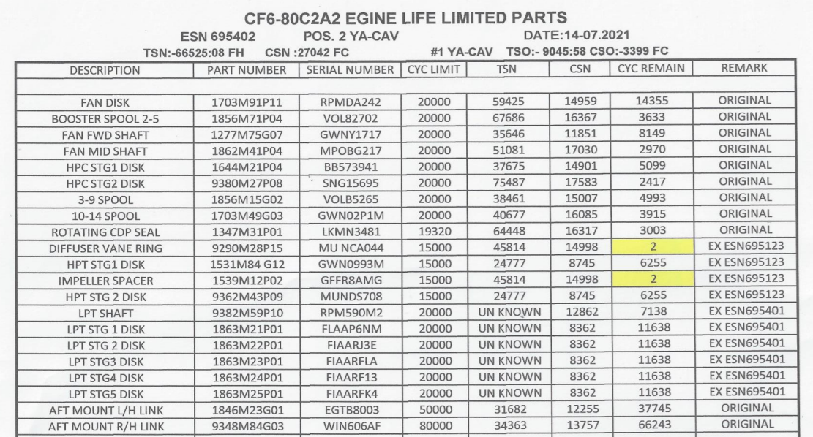

- DOCUMENTATION REQUIRED WITH THE SUBMISSION OF THE QUOTATION
The Supplier shall attach the following documents to its quotation other than the quotation will not process.
- a valid Business License
- Company Certificate of Incorporation;
- ISO9001-2008 Certificate on civil aviation field
- QUOTATIONS VALUATION, EXAMINATION AND DETERMINATION OF RESPONSIVENESS.
- Prior to the detailed evaluation of Quotations, the Purchaser shall determine whether each Quotation:
- meets the Technical criteria;
- SBD has been properly signed.
- Is quotation substantially responsive to the requirements of the SBD?
Note: A substantially responsive Quotation is one which conforms to all the terms, conditions, and specifications of the Standard Bidding Documents.
To evaluate a Quotation, the Purchaser shall only use all the factors, methodologies and criteria defined hereinafter, no other criteria or methodology shall be permitted:
- evaluation will be done for Items or Lots;
- price adjustment for correction of arithmetic errors;
- price adjustment due to discounts offered;
- adjustments due to the application of other evaluation criteria as follows: factors related to the characteristics, performance, and terms and conditions of purchase of the Goods and Related Services; the effect of the factors selected, if any, shall be expressed in monetary terms to facilitate comparison of Quotations;
- Adjustments due to the application of a margin of preference, if applicable.
- The Purchaser’s evaluation of a Quotation will exclude and not take into account:
- In the case of Goods manufactured in the Islamic Republic of Afghanistan, sales and other similar taxes, which will be payable on the goods if the Repair Order is sent to the Bidder;
- in the case of Goods manufactured outside the Islamic Republic of Afghanistan, already imported or to be imported, customs duties and other import taxes levied on the imported Goods, sales and other similar taxes, which will be payable on the Goods if the Repair Order is sent to the Bidder;
- If a Quotation is not substantially responsive, it shall be rejected by the Purchaser, and may not subsequently be made responsive by correction or withdrawal of the nonconforming deviation or reservation.
- No negotiation shall be held with the lowest or any other Bidder.
- A bidder shall not be required, as a condition for award, to undertake responsibilities not stipulated in the Standard Bidding Documents, to have to change its price or otherwise modify its Quotation.
- Correction of Errors
- Quotations determined to be substantially responsive shall be checked by the Purchaser for any arithmetic errors. Errors shall be corrected by the Purchaser as follows:
- where there is a discrepancy between the amounts in figures and in words, the amount in words shall govern; and
- where there is a discrepancy between the unit rate and the line item total resulting from multiplying the unit rate by the quantity, the unit rate as quoted shall govern, unless in the opinion of the Purchaser there is an obviously gross misplacement of the decimal point in the unit rate, in which case the line item total as quoted shall govern, and the unit rate shall be corrected.
- The amount stated in the Quotation shall be adjusted by the Purchaser in accordance with the above procedure for the correction of errors and, with the concurrence of the Bidder, shall be considered as binding upon the Bidder.

G- Model CF6-80C2A2 Engine ESN 695-402 Bore Scope Inspection result

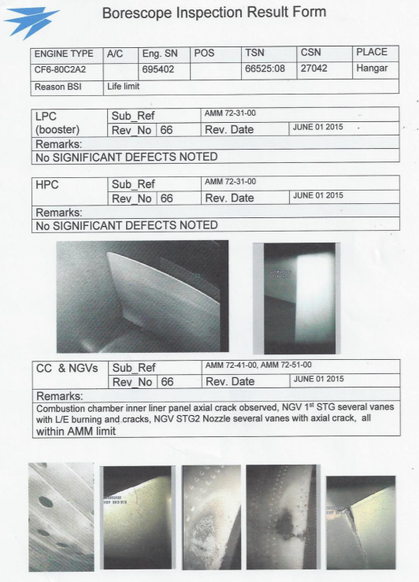

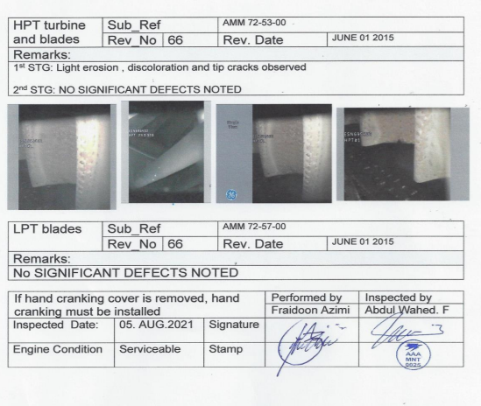

Authorization:
Each vendor has the right to enter into this bidding by offering of better quotation for evaluation and the execution of this SBD must be signed by authorized representative of the vendor
Bidder Representative Name:

Bidder Representative Signature:

Date:

